[1]

Geomagnetic Storms’ Effect on the US Electrical Grid

Garrett Sutherland

*Abstract*—Geomagnetic storms induce currents in electrical conductors that affect the power grid from production and transmission to distribution. These geomagnetically induced currents (GICs) pose a multitude of threats to the power grid because of how it affects transformers and electric signals. This paper utilizes data from historical events to study the effect of GICs on transformers and a small piece of the electric grid. These results are then discussed in the context of the whole US electrical grid and steps that have been taken to mitigate risk.

*Index Terms*—Geomagnetic induced currents, coronal mass ejection, space weather, reactive power

# Introduction

T

he American electrical grid has grown to a complex network of production centers, and transmission and distribution lines that currently amass to more than 300,000 miles of line [1]. As reliance on the American electrical grid increases, the threats against it become more worrying. Understanding exactly how a geomagnetic storm influences the power grid is essential to learning how the grid can be improved and protected against such events. Furthermore it is important to understand geomagnetic storms because they are commonplace in high latitude regions; in 1989 a storm disrupted the power distribution in Quebec causing a blackout [2].

Geomagnetic storms start, often times, with the sun and a coronal mass ejection—a burst of gas and electromagnetic radiation released from the solar corona. When the billion or so tons of plasma (carrying the sun’s magnetic field) reach earth it causes a temporary disturbance of the earth’s magnetosphere [3].

# Theory

Classical electromagnetism is governed almost completely by four equations that Maxwell formulated more than a hundred years ago.

|  |  |  |
| --- | --- | --- |
|  | $$∇∙\vec{E}=\frac{ρ}{ε_{0}}$$ | (1) |
|  | $$\vec{∇}×\vec{E}=-\frac{∂\vec{B}}{∂t}$$ | (2) |
|  | $$∇∙\vec{B}=0$$ | (3) |
|  | $$\vec{∇}×\vec{B}={μ_{0}\vec{J}+μ}_{0}ε_{0}\frac{∂\vec{E}}{∂t}$$ | (4) |

Equations 2 and 4 mathematically describe the interplay between electric and magnetic fields and will be used to find the electric fields produced by the drastic change in magnetic fields.

Perhaps the most vital tool for the analysis of GIC in a simplified model of the grid is Faraday’s law of induction.

|  |  |  |
| --- | --- | --- |
|  | $$ℇ=-\frac{dΦ_{B}}{dt}$$ | (5) |

Which states that the electromotive force, $ℇ$ (Volts), is produced by a changing magnetic flux $Φ_{B}$.

# Formation of GIC

Faraday’s law implies that a disturbance of the Earth’s geomagnetic field induces a geoelectric field at the Earth’s surface. These electrical fields enter the electrical grid through the grounded neutral of wye transformers, and then travel through transmission and distribution lines.

It is difficult to write an analytical expression for these geoelectric fields because they depend heavily on the space weather, currents through the ionosphere and magnetosphere, and secondary effects from induced charges and currents in the Earth [4]. Therefore, it is beneficial to make use of historical data to get an estimate of the scale of GICs. Over the course of the past 100 years, the Earth has been subjected to geoelectric fields that range from 3-15V/km and to 10-50V/km in high latitude areas with good and poor ground conductively respectively [5]. GICs have frequency time scales that range from seconds to days, so it will be assumed that GIC are direct currents (DC) [6]. While this is a simplification, compared to the 60Hz that the US operates on even 1Hz is effectively DC.

# The Electrical Grid

The US electrical grid starts at coal, nuclear, hydroelectric, or smaller industrial power plants where the power is generated. At substations, the voltage is then stepped up (to minimize losses) to between 230kV and 765kV before the power is sent via transmission lines [7]. At the end of the transmission lines are more substations, the voltage is then stepped down before the power is sent via distribution grid. In the US, distribution lines carry the power at voltages between 4kV and 36kV [8]. Finally, at the end of the distribution grid the voltage is stepped down once more at substations to what is used residentially. Transmission and distribution lines come in various sizes (3-40mm), resistances (.05-.4 Ohm per thousand feet), materials, and types [9]. In general, higher voltage lines have larger diameters thus lower resistances and higher voltage substations have lower resistance to ground.

# GIC Effect on Transformers

Most transformers can step voltage because of changing currents (looking at Eq. (4)). A changing electric field, which is responsible for the changing current in the primary circuit, induces a magnetic field that is perpendicular to the change in the electric field. In a transformer, an iron core—the yoke—carries the induced magnetic field, which then induces a current in the secondary circuit as described by Eq. (2).

Fig. 1. Simple ideal transformer

A simple relation can be derived for the relationship of voltages to the number of windings: $V_{2}=\frac{N_{2}}{N_{1}}V_{1}$. Thus an ideal transformer with 85 primary turns for each 4 secondary turns would step a transmission line at 765kV to a distribution line at 36kV. Ignoring losses, the power in both the primary and secondary circuits are equal so with the voltage step comes an opposite step in current.

Using Faraday’s law of induction for N identical turns of wire, it can be seen how a transformer works.

|  |  |  |
| --- | --- | --- |
|  | $$ℇ_{2}=-\frac{dΦ_{2}}{dt}=-\frac{d}{dt}\oint{\vec{A_{1}}}∙d\vec{l_{2}}$$ | (6) |

Where

|  |  |  |
| --- | --- | --- |
|  | $$\vec{A_{1}}\left(r_{2}\right)=\frac{μI_{1}}{4π}\oint{\frac{d\vec{l_{1}}}{r_{12}}}$$ | (7) |

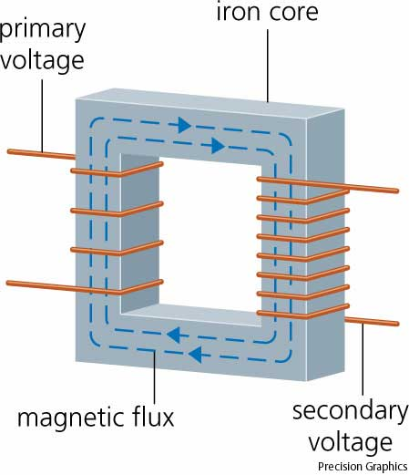Plugging Eq. (7) in Eq. (6) and simplifying by creating a new variable for the mutual induction it can be shown that the induced electromotive force in the secondary circuit is

|  |  |  |
| --- | --- | --- |
|  | $$ℇ_{2}={-M}_{12}\frac{dI_{1}}{dt}$$ | (8) |
|  | $$M_{12}=\frac{μ}{4π}\oint_{1}^{ }{\oint_{2}^{ }{\frac{d\vec{l_{1}}∙d\vec{l_{2}}}{r_{12}}}}$$ | (9) |

The transformers used through the electrical grid are extremely sensitivity to changes in current because their yokes are made of a material with a very high magnetic permeability ( $μ).$ Even small currents can have a large influence: a .5A DC can increase noise by 25db(A) in a high voltage transformer [10].

While noise is unwanted, it is not devastating to the electrical grid. However, a more ominous threat is core saturation. The voltage of a DC through a transformer is added to the voltage of the original alternating current (AC). So, depending on the magnitude of the DC, this asymmetric voltage offset could cause the magnetic yoke to saturate on half cycles of the AC. Typically, a high voltage transformer’s yoke saturates at a magnetic field of 1.6-2.2T [11]. When this threshold is broken the core becomes saturated, which means the core material barely, if at all, responds magnetically to an increase in current. When the core saturates eddy currents form in the surrounding structural components. Incidentally, these structural components are often steel and are not fabricated to conduct magnet fields, so they heat up rapidly. This heat can cause weakening of the structure, insulation, and windings, but this should be minimal given the duration of GICs. Still, there were permanently damaged transformers that resulted from the Quebec storm of 1989 [12].

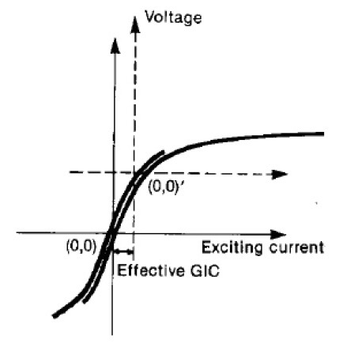To understand how core saturation due to GICs would affect the voltage and currents in a transformer it is assumed that the primary and secondary winding of the transformer are perfect solenoids and that the core is a linear magnetic material. Since the windings are assumed to be perfect solenoids the H field (magnetic field intensity to some) is then, $H(t)=nI\left(t\right)$ where $n$ is number of turns per unit length. Furthermore the magnetic field inside a solenoid is given by $B=μnI$. Thus if the magnetic field of the transformer’s core is modeled as

|  |  |
| --- | --- |
|  |  |

then Faraday’s law says that

|  |  |
| --- | --- |
|  |  |

Thus an electrical grid comprised of ideal transformers would effectively short when a GIC caused a transformer’s core to saturate.

In practice, high voltage transformers do not have linear magnetic cores so the voltage would not drop to zero. However, GICs and the DC voltage would still shift the core away from the near-linear typical operating range and towards saturation where the magnetic response is very small and non linear.

Fig. 2. Transformer’s core response [13]

Potentially the most threating result from a transform’s core saturating is the harmonics that it creates. GICs, providing an asymmetric exciting current, move the transformer’s core into the non-linear region where harmonics of the current are generated. These harmonics are dangerous to the electrical grid because they can erroneously trigger relays throughout the power lines [14]. Static var compensators and capacitor banks, which operate via relays, are responsible for keeping lines at the correct voltage as the reactive power of lines is used. In the event of GICs, these vital components of the grid may not function as designed or may fail from over charging because of a relay tripped by a harmonic. This would allow the voltage in the lines to drop to an ineffectively level, potentially causing a chain reaction of collapsing transmission lines [14].

# Transmission Lines

A full treatment of the effects of GIC on the US electrical grid, including the modeling of geoelectrical fields, ground conductivity, and accurate locations of transformers matched with voltage and phase specifications is beyond the scope of this analysis. Rather, a simple model of three transmission lines between four substations is considered and then the result is considered in the larger context.

The setup for a simple system of electrical substations, which will be solved as a DC circuit for reasons previously described, is as follows

Fig. 3. Schematic of 3 substations with resistance to ground of $R_{ij}$, connected by 100km transmission lines running west to east with resistances $R_{i}$ and induced voltages $E_{i}$

The GIC will be taken to be 1V/km in the west to east direction—parallel to the transmission lines—as is customary in similar analyses. The distance between substations will be taken to be 100km, with the first two transmission lines at 765kV with resistance of 5 Ohms and the third transmission line at 230kV with a resistance of 8 Ohms. The first three substations are taken to have a resistance to ground of .3 Ohm, while the last substation will have a resistance to ground of .5 Ohm, for variety.

This system of circuits can be solved using the mesh grid impedance method. Ohm’s law, which in its simplest form states that

|  |  |  |
| --- | --- | --- |
|  | $$V=IR$$ | (10) |

can be used in matrix form where the voltage and current become column vectors and the resistance becomes a matrix. Kirchhoff’s voltage law states that

|  |  |
| --- | --- |
| $${I_{1}R}_{01}+{I_{1}R}_{1}-\left(I_{2}-I_{1}\right)R_{12}=V_{1}$$ | (11) |
| $${{\left(I_{2}-I_{1}\right)R_{12}+I}_{2}R}_{2}-\left(I_{3}-I_{2}\right)R_{23}=V_{2}$$ | (12) |
| $${{\left(I_{3}-I_{2}\right)R_{23}+I}_{3}R}_{3}+I_{3}R_{34}=V_{3}$$ | (13) |

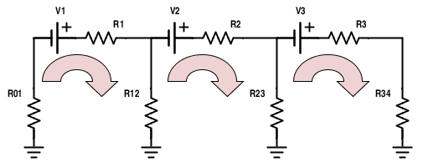So in matrix notation

|  |
| --- |
| R= $\left[\begin{matrix}R_{01}+R_{1}+R_{12} & -R_{12} & 0 \\ -R_{12} & R_{12}+R_{2}+R_{23} & -R_{23} \\ 0 & -R_{23} & R_{23}+R_{3}+R_{23}\end{matrix}\right]$ |
| I= $\left[\begin{matrix}I_{1} \\ I_{2} \\ I_{3}\end{matrix}\right]$ and V= $\left[\begin{matrix}V_{1} \\ V_{2} \\ V_{3}\end{matrix}\right]$ |

Each voltage is $V=1\left[\frac{V}{km}\right]*100\left[km\right]=100$, and the resistances are as previously noted. Solving this matrix equation leads to the following currents in amps.

|  |  |  |
| --- | --- | --- |
| $$I_{1}=18.90$$ | $$I_{2}=19.53$$ | $$I_{3}=12.31$$ |

These are the currents through the respective transmission lines, but the currents to ground (in amps) are given by the sum of currents in the respective ground.

|  |  |
| --- | --- |
| $$I_{01}=-18.90$$ | $$I_{12}=-.63$$ |
| $$I_{23}=7.22$$ | $$I_{34}=12.31$$ |

Despite the voltage sources due to GIC being modeled in the transmission lines, [14] gives evidence that the results are the same as when the voltage sources are placed at the grounds.

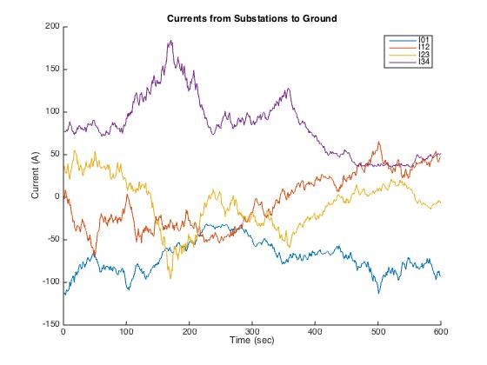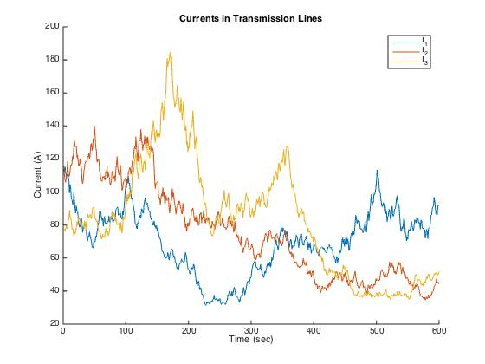The modest assumption of a 1V/km horizontal geoelectric field still shows effects on currents in a substation system due to a GIC that is perfectly aligned with a transmission system. While these currents are not astronomical, it only takes a small current to saturate transformer cores.

A Matlab script was written to elaborate on this system. It generated a random initial value for the geoelectric field between 0 and 15V/km and for the direction of the field between 0 and 2 $π$. These values were taken as the initial values of the first transmission line. The initial values for the second transmission line were randomly generated within 20% of the first line’s values. The third transmission line took initial values randomly generated within 20% of the second line’s values. Finally, for ten minutes both the field strength and direction for each transmission line were randomly stepped within 20% of the previous value at each second. The purpose behind the method of generation of the initial values and the stepping was that the geoelectric field changed in a semi-smooth yet random manner. The induced currents in the transmission lines and the substations to ground from one trial were as follows.

After running the script many times it was clear there was little to no relation between the outcomes. If a unifying conclusion was to be made, it did appear that the substation at the ends of the system had the highest induced currents. This would imply that power generation and utilization ends of the electrical grid are most at risk for transformer core saturation, and by association, for power outages to originate.

Certainly, each geomagnetic storm would affect the electrical grid differently based on its magnitude and direction. This was evident by running the script many times and observing the lack of patterns. Peak currents as high as 300 amps and as low as 20 amps were observed over the course of just ten trials. Many more thorough analyses agree that 100 amps could be sufficient for half-cycle saturation for the cores of some transformers [17]. This is because typically the magnetizing current of a transformer is under 10 amps.

# Mitigating the Problems

Fortunately, the US electrical grid has a variety of solutions intended to mitigate events previously described. For instance, many high voltage transformers utilized a core with an air gap (imagine a break in the yoke of Fig. 1.). While an air gap increases the flux leakage (magnetic flux leaked to the surrounding environment), it decreases the effect of a GIC (and DCs). This air gap effectively reduces the magnetic permeability of the core, thus allowing for larger DC disturbances before the core is saturated.

Another safety feature of the electrical grid is the heat management systems incorporated in today’s transformers. Most transformers are designed to dissipate heat in a variety of ways including the utilization of oil to keep components cool. However, in the event of overheating some transformers have alarms that are trigger.

Transformers are also protected against even harmonics (more harmful than odd harmonics due to being a 3 phase system) by both traditional and adaptive methods that can respond to both the magnitude and phase angle of even harmonics [16].

References

1. "What Is the Electric Power Grid and What Are Some Challenges It Faces?" *U.S. Energy Information Administration*. N.p., 16 Sept. 2014. Web. 03 May 2015. <http://www.eia.gov/energy_in_brief/article/power_grid.cfm>.W.-
2. Odenwald, Sten. "The Day the Sun Brought Darkness." *NASA*. NASA, n.d. Web. 03 May 2015. <http://www.nasa.gov/topics/earth/features/sun_darkness.html#.VUZsHM7duB4>.
3. "Geomagnetic Storms." *SPACE WEATHER PREDICTION CENTER NATIONAL OCEANIC AND ATMOSPHERIC ADMINISTRATION*. N.p., n.d. Web. 3 May 2015. <http%3A%2F%2Fwww.swpc.noaa.gov%2Fphenomena%2Fgeomagnetic-storms>.
4. Pirjola, R. "Geomagnetically Induced Currents during Magnetic Storms." *IEEE Transactions on Plasma Science* 28.6 (2000): 1867-873. Web.
5. Pulkkinen, A., E. Bernabeu, J. Eichner, C. Beggan, and A. W. P. Thomson. "Generation of 100-year Geomagnetically Induced Current Scenarios." *Space Weather: The International Journal of Research and Applications* 10 (2012): n. pag. Web. 10 May 2015.
6. Wik, M., A. Viljanen, R. Pirjola, A. Pulkkinen, P. Wintoft, and H. Lundstedt. "Calculation of Geomagnetically Induced Currents in the 400 KV Power Grid in Southern Sweden." *Space Weather* 6.7 (2008): n. pag. Web.
7. "Top 9 Things You Didn't Know About America's Power Grid." *Energy.gov*. US Department of Energy, n.d. Web. 08 May 2015. <http://energy.gov/articles/top-9-things-you-didnt-know-about-americas-power-grid>.
8. "Primary Distribution Voltage Levels." *EEP Electrical Engineering Portal RSS*. N.p., n.d. Web. 08 May 2015. <http://electrical-engineering-portal.com/primary-distribution-voltage-levels>.
9. "ACSR Overhead Power Cable." *Allied Wire and Cable*. N.p., n.d. Web. 09 May 2015. <http://www.awcwire.com/part.aspx?partname=swanate>.
10. *Seimens AG Energy Sector*. 2012. Compensation of Direct Current. Germany, Erlangen.
11. Jones, G. R., M. A. Laughton, and M. G. Say. *Electrical Engineer's Reference Book*. 16th ed. Oxford: Butterworth-Heinemann, 1993. Print.
12. Arabi, S., M. M. Komaragiri, and M. Z. Tarnawecky. "Effects of Geomagnetically-induced Currents in Power Transformers from Power Systems Point of View." *Canadian Electrical Engineering Journal* 12.4 (1987): 165-70. Web.
13. Kappernman, J.g., and V.d. Albertson. "Bracing for the Geomagnetic Storms." *IEEE Spectrum* 27.3 (1990): 27-33. Web.
14. Hutchins, Trevor. "Geomagnetically Induced Currents and Their Effect on Power Systems." Thesis. University of Illinois at Urbana-Champaign, n.d. *Ideals Illinois*. 2012. Web. 9 May 2015. <https://www.ideals.illinois.edu/bitstream/handle/2142/30963/Hutchins_Trevor.pdf?sequence=1>.
15. Boteler, D.h., and R.j. Pirjola. "Modelling Geomagnetically Induced Currents Produced by Realistic and Uniform Electric Fields." *IEEE Transactions on Power Delivery* 13.4 (1998): 1303-308. Web. 10 May 2015.
16. *Transformer Protection Principles*. N.p.: GE Digital Energy, n.d. PDF.
17. Kirkham, H., J. E. Dagle, Y. V. Marakov, J. G. DeSteese, M. A. Elizondo, and R. Daio. "Geomagnetic Storms and Long-term Impacts on Power Systems." *Geomagnetic Storms and Long- Term Impacts on Power Systems* (2011): n. pag. *Pacific Northwest Nation Laboratory*. Department of Energy. Web. 10 May 2015. <http://www.pnnl.gov/main/publications/external/technical_reports/PNNL-21033.pdf>.

Code

%Initialize Electrical grid

r01=.3;

r12=r01;

r23=r01;

r34=.5;

r1=5;

r2=5;

r3=8;

r=[r01+r1+r12, -r12, 0;-r12,r12+r2+r23,-r23;0,-r23,r23+r3+r23];

%Initialize Geoelectric field

minutes=10;

GICpts=10*60;

I=zeros(3,GICpts);

I_2_ground=zeros(4,GICpts);

min=0;

max=15;

magnitude(1,1)=(max-min)*rand(1,1)*100;

magnitude(2,1)=magnitude(1,1)+.05*(-1+2*rand(1,1))*magnitude(1,1);

magnitude(3,1)=magnitude(2,1)+.05*(-1+2*rand(1,1))*magnitude(2,1);

for i=2:GICpts

magnitude(:,i)=magnitude(:,i-1)+.05*(-1+2*rand(3,1)).*magnitude(:,i-1);

end

angle(1,1)=(2*pi)*rand(1,1);

angle(2,1)=angle(1,1)+.05*(-1+2*rand(1,1))*angle(1,1);

angle(3,1)=angle(2,1)+.05*(-1+2*rand(1,1))*angle(1,1);

for i=2:GICpts

angle(:,i)=angle(:,i-1)+.05*(-1+2*rand(3,1)).*angle(:,i-1);

end

effect=magnitude.*sin(angle);

for i=1:GICpts

I(:,i)=r\effect(:,i);

I_2_ground(:,i)=[-I(1,i);I(1,i)-I(2,i);I(2,i)-I(3,i);I(3,i)];

end

%More plots for visualization, not used in analysis

%{

figure

names={'I01';'I12';'I23';'I34';'I_1';'I_2';'I_3'};

for i=1:7

if i<=4

name=sprintf('Current to Ground for %s',names{i});

subplot(2,4,i)

plot(I_2_ground(i,:))

title(name)

xlabel('Time (sec)')

ylabel('Current (A)')

end

if i>4

name2=sprintf('Current for %s',names{i});

subplot(2,4,i)

plot(I(i-4,:))

title(name2)

xlabel('Time (sec)')

ylabel('Current (A)')

end

end

%}

figure

title('Currents from Substations to Ground')

xlabel('Time (sec)')

ylabel('Current (A)')

hold on

for i=1:4

plot(I_2_ground(i,:))

end

legend('I01','I12','I23','I34')

hold off

figure

title('Currents in Transmission Lines')

xlabel('Time (sec)')

ylabel('Current (A)')

hold on

for i=1:3

plot(I(i,:))

end

legend('I_1','I_2','I_3')

hold off

1.